FinVerse: One Touch Finance Platform
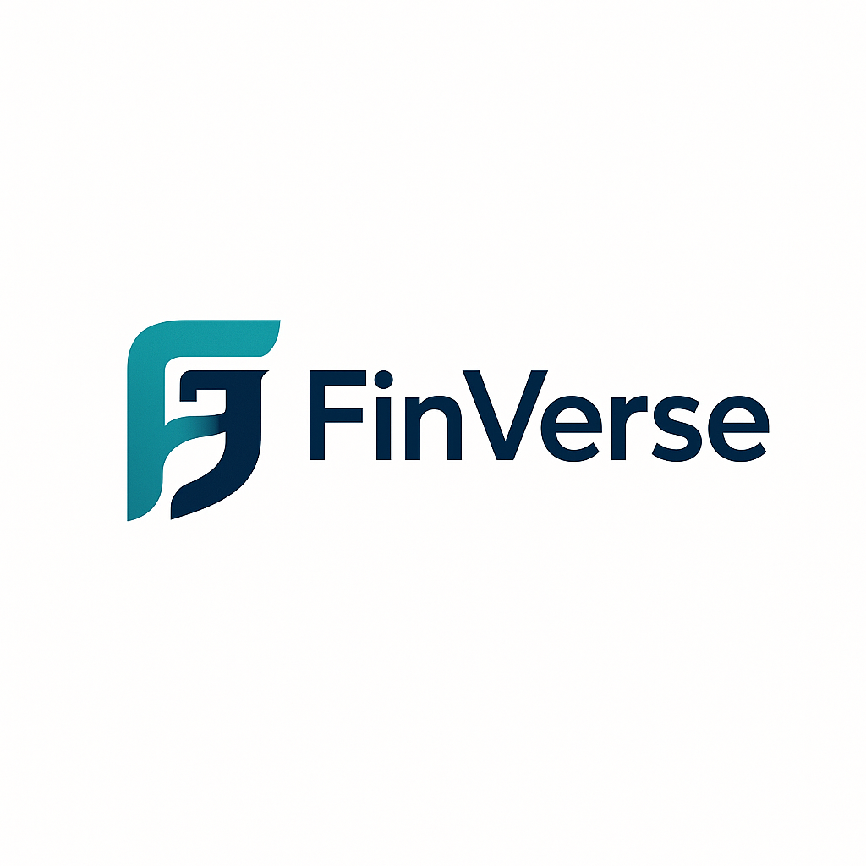
Course: ISM 6155 – Enterprise Information Systems Management

Group: E

Team Members:
Subham Mohanty Hetesh Krishna Saanvi Reddy




Koushik Reddy Shree Durga


Table of Contents
- Executive Summary ………….……………………………………………………………(3-4)
- Introduction and Organizational Context…………………………………………..(4-5)
- Value Exchange Framework…………………………………………………………….(5-6)
- Current State Assessment……………………………………………………………,,.(6-7)
- AI Implementation Opportunities…………………………………………………….(7-8)
- Risk Analysis and Ethical Framework (HEVIDS)………………………………..(8-9)
- Proposed System Architecture and Technologies……………………………(9-11)
- Integration and Deployment Strategy…………………………………………….(12-13)
- Governance and Compliance Measures………………………………………..(13-14)
- Training and Development Strategy………………………………………………(14-15)
- Implementation Timeline and Budget………………………………………….(15-17)
- Evaluation and Continuous Improvement………………………………….…(17-18)
- Data Management and Security Architecture………………………….……(18)
- Product Roadmap and Go-to-Market Strategy …………………..…………(18)
- Financial Model and ROI Forecast…………………………………….……….(19)
- Risk Register and Mitigation Strategies……………….……………………..(19)
- Demo Slide………………………………………………………………………………(19-20)
- Conclusion……………………………………………………………………………...(20)

Problem-Managing personal and business finances requires switching between multiple unconnected tools for tax filing, investment tracking, and insurance management — causing data silos, manual errors, and security vulnerabilities.
Idea - Develop an AI-driven unified financial platform that integrates tax, investment, and insurance modules through microservices architecture, ensuring automation, transparency, and compliance.
Solution (Tech Summary)-FinVerse uses a FastAPI backend connected to MongoDB for scalable data management, with LangChain-based AI orchestration to automate financial Insights and chatbot assistance.
A blockchain audit layer ensures traceability, while Docker–Kubernetes deployment and AWS/Azure integration provide scalability and security.
This hybrid system reduces human effort, enhances decision accuracy, and maintains ethical AI governance through the HEVIDS framework.
- Executive Summary
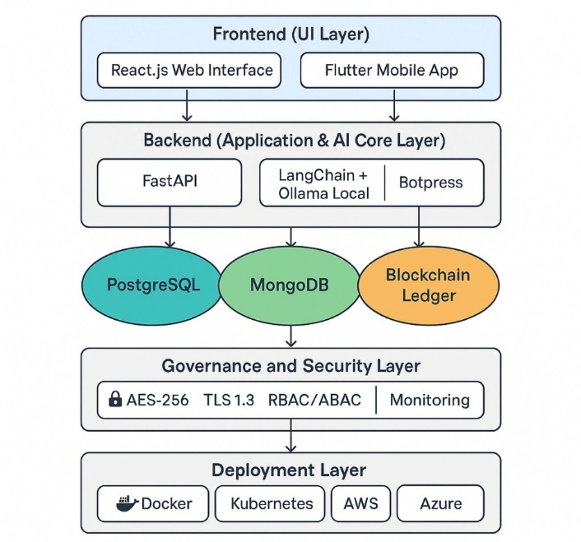
Finverse is a next-generation financial technology platform powered by artificial intelligence that makes it easier for people and businesses to handle their money. In today's world of money,people often must use several separate tools to file their taxes, keep an eye on their investments, and handle their insurance. This splitting up makes things less efficient, causes data to be duplicated, and raises security issues. Finverse solves these problems by bringing these important functions together into one ecosystem that runs on responsible artificial intelligence. The goal of this project is to create and present a complete AI Implementation Strategy for Finverse that is in line with ethical principles, enterprise-system frameworks, and the creation of long-term business value.
FinVerse Enterprise AI Architecture – Integrating Finance, Data, and Trust
Finverse wants to make money management as easy as talking and as safe as a vault. Finverse gives you real-time insights, predictive analytics, and clear decision-making support through smart automation and ethical design. The platform uses hybrid AI architecture that combines Gemini 1.5 Flash, a powerful cloud-based reasoning engine, with Ollama Local AI for processing that happens only on the device. This design strikes the perfect balance between privacy and intelligence. It keeps sensitive data safe while still allowing for advanced analysis. The backend of the system, which was built with FastAPI, connects all the functional modules tax filing, investment tracking, and insurance management—through a central AI core. This core is backed by Mongo DB, PostgreSQL databases, and a blockchain-based audit layer that makes it easy to keep track of everything.
Finverse wants to make a difference that can be measured across its network of stakeholders. Customers get faster and more accurate financial services; partners and regulators get clear audit trails, and the business itself runs more smoothly. Combining explainable AI models with blockchain transparency makes it possible to check every recommendation and transaction. Finverse is expected to cut operating costs by about 30%, make financial reporting more accurate, and boost overall trust in Digital Finace. Finverse's design philosophy is built on ethics and good governance. The HEVIDS framework—Harmony, Ethics, Veracity, Integrity, Discernment, and Safeguards—is used in the project to make sure AI is used responsibly. We keep an eye on each AI process to make sure it is fair, accurate, and accountable. Finverse meets international standards for privacy and security, like ISO 27001, SOC 2, and GDPR. This gives users peace of mind that their data is safe, and their privacy is respected.
Finverse wants to be the main AI backbone for digital finance by 2030. It wants to serve international markets in many languages while staying fully compliant with all laws and ethical standards. The project shows not only new technology, but also how enterprise information-system strategies can bring together technology, organization, and ethics to make social and business value. Finverse is the future of managing money. It is a clear, smart, and human-centered system where AI and honesty work together to make every transaction more trustworthy and efficient.
2. Introduction and Organizational Context
Artificial intelligence and digital technologies are changing the financial world in a big way. Even though there are more online financial tools than ever before, people and small businesses still have a common problem: managing their taxes, insurance, and investments on multiple platforms. This fragmentation leads to mistakes, inefficiencies, and worries about security. Finverse was made to fix this problem by bringing together these important financial services into one smart platform powered by AI.
Finverse's goal is to make money smart, simple, and responsible. Its goal is to make financial processes easier by automating them while still being open, safe, and morally responsible. Finverse lets users get real-time insights, make better financial decisions, and do less work by using AI models for automation and decision support. The Information Systems Strategy Triangle (Pearlson et al., 2023) says that business goals, organizational design, and technology strategy should all work together. This approach fits with that idea.
Finverse works in the fast-changing FinTech industry and meets the growing need for safe and moral automation. The three main service modules are:
- Tax Automation – Uses natural language processing to extract, validate, and file tax data automatically.
- Investment Analytics – Employs predictive algorithms for performance tracking and portfolio diversification.
- Insurance Management – Utilizes AI-driven risk assessment models to evaluate claims and optimize coverage.
Finverse uses a modular microservices architecture like ERP systems, which lets each service work on its own but still connects through a central AI Core. This makes sure that the system can grow, that data can flow in real time, and that it is reliable. Blockchain integration makes things more open by keeping an unchangeable record of every transaction and AI decision.

Purpose of Proposal:
The goal of this proposal is to create and share a detailed AI Implementation Strategy for Finverse that shows how AI can be used to not only automate financial processes but also build trust, accuracy, and ethical integrity in the digital finance space.
The proposal explains how AI can turn Finverse into a single platform that can analyze huge amounts of financial data, create personalized insights, and stay in line with financial rules. Through automation, explainable AI, and data governance, it wants to make things better for users, financial partners, and regulators.Finverse's strategic goal is to create a responsible AI model that strikes a balance between innovation and governance in a FinTech world that is becoming more and more competitive and shaped by AI-first systems. The plan calls for the creation of the Finverse Intelligent Finance System (FIFS), a modular platform that combines machine learning, predictive analytics, and ethical AI principles. FIFS will help Finverse cut costs, make things more accurate, and boost user trust by giving clear, understandable recommendations.
Finverse wants to set the standard for ethical financial innovation by using this AI strategy. The system will follow the HEVIDS Framework (Harmony, Ethics, Veracity, Integrity, Discernment, Safeguards) and international standards like ISO 27001, SOC 2, and GDPR. These steps make sure that AI stays fair, safe, and able to be checked while it works.
The proposal basically lays out a plan for turning Finverse into a next-generation financial ecosystem that uses AI and combines technology, governance, and ethics to create long-term value for businesses and society.
3. Value Exchange Framework
Finverse brings together different financial services that are usually spread across multiple apps or websites. By combining them into one secure platform, users can manage everything more easily. The system uses AI to read and analyze data, suggest tax deductions, track investment performance, and check insurance coverage automatically.
For example, instead of filling in long tax forms or switching between tools, a user can upload their documents once, and Finverse’s AI will handle calculations and show results instantly. This not only saves time but also reduces the chance of errors.
Stakeholders and the Value They Get:
Stakeholder | Value They Receive | How to Finverse Delivers?
Customers (Individuals & Small Businesses) | Easy-to-use financial management, less paperwork, faster results, and better insights. | AI tools for automation, personalized dashboards, and real-time recommendations.
Financial Partners (Banks & Insurers) | Access to verified data, reduced reporting time, and tools for better decision-making. | Secure API connections and AI reports that summarize user trends and needs.
Regulators | Clear audit records and transparent tracking of financial actions. | Blockchain-based logs that record all transactions and AI decisions securely.
Finverse Organization | Stable income from subscriptions and partnerships, and lower internal costs. | Cloud automation and local AI systems reduce operating expenses.

How Finverse Delivers Value
- 1. Automation:
AI models take care of repetitive work like data entry, tax form filling, and compliance checks. This allows users to focus on decisions rather than manual tasks.
- Transparency and Trust:
Every action and AI decision is recorded through blockchain audit logs, so users and regulators can always trace where data came from and how it was used.
- Ethical AI:
Finverse follows the HEVIDS framework to make sure its AI is fair, accurate, and secure. It protects user data, explains its outputs, and avoids bias in recommendations.
In simple terms, Finverse helps users save time, reduces errors, and builds trust through secure and ethical technology. Customers get faster and smarter financial tools, partners get reliable data and insights, regulators get transparency, and the company gains growth and sustainability. This balanced exchange of benefits ensures that every part of the ecosystem contributes to and benefits from Finverse’s success.
4. Current State Assessment:
The current enterprise architecture of Finverse is built as a modular and scalable system that integrates its three major financial components—tax management, investment analytics, and insurance services—into a single unified framework. The platform is built on three layers: the data layer, the application layer, and the presentation layer. The presentation layer has a web and mobile interface that lets users access all of the financial tools through an interactive dashboard. This interface also has an AI-powered chatbot made with Gemini 1.5 Flash that lets users talk to the system naturally to do things like estimate taxes, keep track of insurance claims, and keep an eye on investments.
The application layer is the most important part of the Finverse system. FastAPI is used to build it. This lets different services work on their own while still being able to talk to each other through secure APIs. The AI engine is a mix of Gemini 1.5 Flash for learning in the cloud and Ollama Local AI for processing on the device itself. This method keeps high computational performance while keeping data safe. PostgreSQL databases help the architecture by storing structured financial data, and blockchain audit logs keep track of every AI-generated recommendation and user transaction. All these parts work together to make a structure that is reliable and open, which builds trust and compliance.
Finverse's current information systems are linked to each other so that operations and governance go smoothly. Finverse can give each user a unique experience because it has a Customer Relationship Management (CRM) system that keeps track of user accounts and communications. The analytics and monitoring system was built using ML flow and Streamlit, tracks performance metrics such as AI accuracy, bias detection, and response time. The compliance and governance system makes sure that the company follows international rules like ISO 27001 and GDPR. This helps the company keep sensitive financial data safe and keep the trust of regulators. Lastly, the audit and reporting system uses blockchain to make sure that all AI decisions are clear and can be checked, which gives regulators and partners full trust in the data accuracy.
Finverse is in a good place overall, with modern architecture, ethical AI design, and open governance. The platform does a good job of connecting all of its modules into one ecosystem while still being open to adding more in the future. Finverse is still a new company, so it needs to keep working on its integration with outside partners and building its infrastructure to meet the needs of more users. Even though these are problems, its strong design, ethical use of data, and culture of innovation give it an edge over other FinTech companies that are changing.
5. AI Implementation Opportunities:
Finverse's main goal is to build a single, smart, and efficient financial ecosystem, and AI is a big part of how they plan to do this. The platform uses AI not just as a technical tool, but also to add business value, make decisions easier, and build trust with users. Finverse uses AI in many parts of its business to make financial processes easier, more open, and more in line with ethical and legal standards.
Automated tax processing is one of the most important ways that AI adds value to Finverse. Finverse doesn't make users enter data or figure out how much tax they owe by hand. Instead, it uses natural language processing and document recognition models to automatically pull information from uploaded forms and receipts. This system cuts down on mistakes, finds possible deductions, and makes sure that tax returns follow local rules. The AI model gets better at filing by learning from past filings. This makes the process easier and more reliable for users.
Personalized investment insights are another important use of AI in Finverse. The system looks at market data, spending patterns, and user goals to suggest the best investment options. It does this by using machine learning and predictive analytics. These insights are updated in real time, which helps people make better and faster choices about their money. The AI not only makes predictions, but it also explains why it made those predictions. This helps users understand financial trends and trust the platform's suggestions.
AI is also using a lot to figure out how risky an insurance claim is and how likely it is to happen. Finverse uses data-driven models that look at past claims data to figure out possible risks and find strange patterns that could be signs of fraud. When someone files a claim, AI helps check the documents, compare them to past data, and quickly approves the claim. This automation cuts down on the need for manual review, speeds up the processing of claims, and makes insurance decisions fairer and more consistent.
Another important area where AI can be used is fraud detection and data security. Finverse works with sensitive financial data, so it uses machine learning models that can find unusual patterns like duplicate transactions, sudden spikes in spending, or changes in how users act. These models are always watching data streams and will let admins or users know right away if there is a possible security breach. When used with blockchain audit logs, this method makes every transaction very trustworthy and easy to trace.
AI also makes customer support and engagement better by adding an intelligent chatbot to the Finverse platform. Gemini 1.5 Flash powers the conversational assistant, which can answer questions, send financial reminders, and help users with complicated tasks like filing taxes or reviewing investments. Finverse's AI assistant is different from regular chatbots because it understands the context and history of the user, which lets it respond naturally and gives relevant answers. This makes users feel like they have support and makes the experience more interactive.
Lastly, Finverse uses AI to keep an eye on compliance and governance. Finverse's AI helps the company stay compliant by automatically keeping track of data privacy policies, user consent records, and new rules. Financial systems must follow strict legal and ethical standards. It makes reports on compliance and points out any possible policy violations. This proactive monitoring makes sure that Finverse stays compliant with standards like GDPR, ISO 27001, and SOC 2, while also making sure that all AI operations are fair and open.
AI helps Finverse in almost every part of its ecosystem, from security and governance to automation and personalization. These apps help the platform do less manual work, work more efficiently, and stay morally responsible. As Finverse grows, its responsible and open use of AI will continue to be the main source of new ideas. This will make managing money smarter, safer, and easier for everyone.

6. Risk Analysis and Ethical Framework (HEVIDS):
Finverse needs to be careful and stay morally responsible as it keeps using advanced AI in its business. Private user data is handled by financial systems, which also make decisions on their own and follow the rules. There are risks that come with all of these things, such as bias, privacy violations, or system abuse. Finverse uses the HEVIDS framework (Harmony, Ethics, Veracity, Integrity, Discernment, and Safeguards) to solve these issues. This makes sure that its AI systems are fair, open, and responsible for the rest of their lives.
Harmony, the first part, talks about how important it is to find a balance between automation and human control. Finverse makes sure that AI doesn't take over human decision-making; instead, it works with it. For example, a person must approve all major financial decisions, such as moving a lot of money or changing a policy, before they can be carried out. This balance lets the organization stay in charge and not have to rely on fully automated systems as much.
Finverse's AI governance model is based on morals. All algorithms are designed to be fair and not show bias. Finverse checks its data sets and AI outputs on a regular basis to make sure they are not biased. It also makes things clear by explaining how AI makes decisions, which helps people understand why a certain result or recommendation happened. Finverse's data-handling rules also make sure that they follow international ethical standards like GDPR and ISO 27001. This lets users have full control over their own data.
The third pillar, Veracity, is about making sure that the AI models use real and correct data. Finverse only gets financial data from banks, insurance companies, and government tax databases that it trusts. Automated validation tools find and get rid of duplicate or incorrect entries, which keeps the data quality high. This method stops false reports or predictions that could lead users to make bad financial decisions.
Integrity means that you can see and follow all AI-driven processes. Finverse uses blockchain technology to keep a record of every AI decision, transaction, and data update that can't be changed. This makes sure that only people who have permission can check on all actions at any time. By being this accountable, Finverse earns users' trust and protects itself from possible abuse or data manipulation.
The Discernment principle makes sure that people use Finverse's AI systems in a smart and responsible way. Employees get regular training on how to read AI suggestions and when they need to step in and do things by hand. The system is set up to mark results that are unclear or not very certain, so people can look them over instead of making decisions on their own. This method, which includes a person in the loop, makes it less likely that you'll get the wrong or unintended results.
Finally, safeguards include the technical and procedural steps that protect the platform from risks like data breaches, misuse, or access without permission. Finverse has a lot of security features, like encryption, access control, and constant system monitoring. AI-based tools that look for unusual behavior and send out alerts right away. Regular vulnerability tests, backups, and plans for dealing with incidents help keep the system safe and strong against threats from both inside and outside.
To sum up, the HEVIDS framework gives Finverse a clear way to handle AI-related risks in a way that is both moral and useful. Finverse builds long-term trust with its users, partners, and regulators by making sure that its operations are based on harmony, ethics, truthfulness, integrity, discernment, and safety. These steps make sure that innovation and responsibility go hand in hand, which lets Finverse run as a safe, honest, and ethical AI-powered financial system.
7. Proposed System Architecture and Technologies:
The technical implementation of Finverse is based on a hybrid AI enterprise architecture that tries to find a balance between performance, scalability, and data privacy. The system combines cloud computing, local AI processing, and blockchain-based auditing into one platform that works well together. The structure supports the organization's main goal of providing smart and ethical financial automation that is in line with its core values of trust, openness, and giving users power.
FinVerse Aura – The AI Intelligence Layer
FinVerse Aura is the intelligence core of the FinVerse ecosystem — the layer that gives the platform its ability to understand, reason, and respond ethically. Aura is designed to connect all microservices, databases, and user interfaces through a unified conversational and analytical engine.Technically, Aura integrates LangChain, FastAPI, and Botpress to power conversational automation while securely interfacing with MongoDB for context retention. It uses Gemini 1.5 Flash for high-level cloud reasoning and Ollama Local AI for on-device processing, ensuring that sensitive financial data stays private.
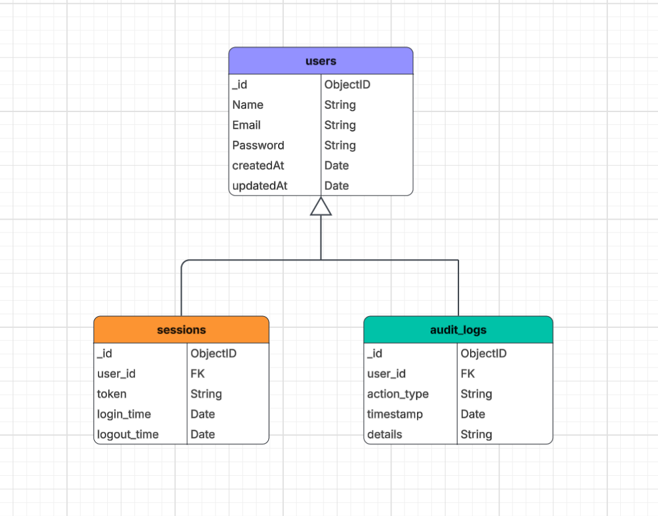
Figure : MongoDB Logical ERD for FinVerse Authentication and Audit System
The figure shows how MongoDB collections — users, sessions, and audit_logs — interact to support authentication, secure session management, and immutable audit tracking in FinVerse.
This structure ensures transparency, accountability, and efficient user governance.

The purpose of Aura is to turn FinVerse into an interactive, human-like financial intelligence assistant that automates tax, investment, and insurance workflows. Aura can analyze uploaded documents, extract financial patterns, and generate personalized insights — all within ethical boundaries defined by the HEVIDS framework (Harmony, Ethics, Veracity, Integrity, Discernment, and Safeguards).
Aura also forms the foundation for future expansion into voice-driven finance, predictive behavioral analytics, and explainable AI dashboards. Its hybrid architecture ensures both speed and data sovereignty, making it the heart and soul of FinVerse’s next-generation financial automation.
AI Bot Architecture

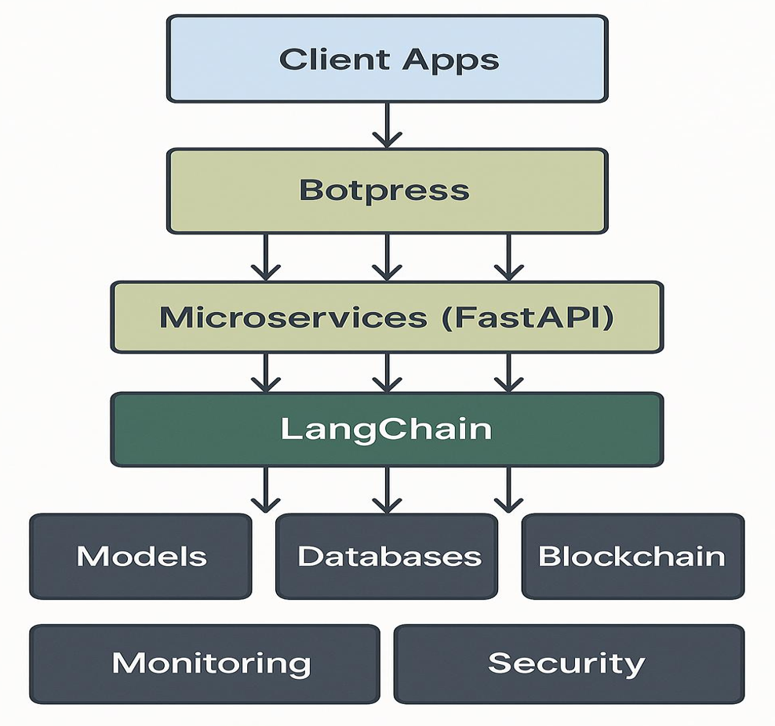

Figure : FinVerse Apps → Botpress → Microservices (FastAPI) → LangChain → Models/Databases/Blockchain with Monitoring & Security layers.

The following layers make up the architecture:
1. User Interface Layer (Front-End):
- It has a dashboard for the web and mobile that was made with React.js and Flutter.
- Let people do all their financial tasks, like filing taxes, keeping track of investments, and managing insurance, in one place.
- Includes an AI chatbot that runs on Gemini 1.5 Flash and can help with financial questions, advice, and document analysis in real time.
2. Application & AI Core Layer (Back-End Processing):
- Built with FastAPI, which lets tax, insurance, and investment modules run as separate microservices.
- It uses a hybrid AI system that combines Gemini 1.5 Flash ,Bot for cloud-based analytics and Ollama Local AI for private computations on the device.
- Use LangChain to control AI and MLflow to keep an eye on how well the model works, how fair it is, and how biased it is.
- Use secure RESTful APIs to talk to other modules and third-party systems like banks and insurance companies.
3. Data & Governance Layer (Storage and Security):
- Use PostgreSQL to store structured data, with AES-256 encryption and strict controls on who can access it.
- Use blockchain technology to keep records of all financial transactions and AI-driven decisions that can't be changed.
- Use AWS S3 to back up data in case of loss or disaster.
- Keeps up with the standards set by GDPR, ISO 27001, and SOC 2.
4. Infrastructure & Deployment Layer (Operations and Scalability):
- Use Docker and Kubernetes to deploy and scale microservices in containers.
- Works on both the AWS and Azure cloud platforms, which makes it very available and accessible around the world.
- Use GitHub Actions for continuous integration and deployment (CI/CD), which makes sure that updates go smoothly.
- Use AWS GuardDuty and Azure Sentinel to keep an eye on system health and security in real time.
This layered architecture fits with Finverse's business strategy because it makes sure that things are done quickly, clearly, and in a way that can change. It helps the company achieve its goal of making finance simple, smart, and responsible while also keeping data privacy and compliance at the highest levels.

8. Integration and Deployment Strategy:
The integration and deployment strategy for Finverse is designed to ensure smooth coordination among all modules, continuous scalability, and strict alignment with the company’s ethical and business goals. Since Finverse connects multiple financial services such as tax, investment, and insurance under one platform, the system integration is built around modular microservices and secure API communication. This ensures that data flows seamlessly between internal systems and external partners like banks, insurers, and regulators while maintaining privacy and compliance with standards such as GDPR and ISO 27001.
Finverse adopts a phased integration and deployment approach to minimize operational risks and allow stepwise validation during each stage of development.
- Phase 1 – Foundation and Planning:
This phase establishes the project’s foundation by identifying core technologies, forming the development team, and finalizing security and compliance frameworks. Pilot modules like the AI chatbot and tax automation service are built in a sandbox environment, and their performance is validated before scaling.
- Phase 2 – Pilot Integration:
The second phase focuses on testing the interaction between Finverse’s AI components, including FastAPI microservices, Gemini 1.5 Flash, and Ollama Local AI. Pilot deployment is done for a limited set of users to evaluate accuracy, response time, and system interoperability. Early feedback helps refine data flow, user experience, and performance tuning.
- Phase 3 – System Refinement and Evaluation:
Based on pilot outcomes, system optimizations are carried out. The AI models are retrained to improve accuracy, reduce bias, and enhance prediction of reliability. Monitoring tools such as MLflow and Streamlit dashboards are used to track key performance indicators like automation success rates, data quality, and model fairness.
- Phase 4 – Scaled Deployment:
Once the system stabilizes, Finverse moves to large-scale deployment across its full user base. Infrastructure on AWS and Azure is scaled using Docker and Kubernetes, enabling real-time operations and load balancing. Training programs are conducted to familiarize employees and early users with new AI features, ensuring ethical and responsible usage.
- Phase 5 – Optimization and Continuous Governance:
In the final phase, Finverse focuses on continuous improvement. Governance dashboards are used to monitor compliance, security, and performance. The blockchain audit system ensures every AI decision remains traceable, and retraining cycles are scheduled regularly to adapt models to new data and regulatory updates.
Throughout these phases, integration is handled using secure RESTful APIs that link Finverse’s internal modules and partner systems. Each API connection uses OAuth 2.0 authentication and SSL encryption, ensuring that external collaborations happen securely. The containerized microservice model, managed by Docker and Kubernetes, allows each Finverse component to operate independently, which simplifies troubleshooting and future updates. Automated CI/CD pipelines through GitHub Actions enable rapid, reliable code deployment and AI model updates without affecting ongoing operations.

Deployment Considerations
Several factors are considered to ensure that deployment supports Finverse’s overall business and ethical strategy:
- Security and Compliance:
All modules follow strict encryption and access control policies. Real-time monitoring with AWS Guard Duty and Azure Sentinel helps detect anomalies and mitigate security threats.
- User Roles and Access Management:
Different user groups—customers, analysts, regulators, and administrators—are assigned roles with specific privileges to prevent data misuse while promoting transparency.
- Integration Flexibility:
APIs are designed with interoperability in mind, enabling Finverse to easily connect with external banking, tax, or insurance systems as it grows.
- Scalability and Reliability:
Using cloud-native infrastructure allows Finverse to handle fluctuating workloads efficiently, supporting business expansion and future product additions.
- Change Management and Training:
Training programs accompany each deployment phase, ensuring all stakeholders understand system capabilities, ethical use of AI, and data handling protocols.
- Business Alignment:
Each phase and integration milestone directly aligns with Finverse’s mission—to automate financial processes responsibly, enhance customer trust, and promote transparency in AI-driven decision-making.

9. Governance and Compliance Measures:
Finverse's governance and compliance framework makes sure that all AI, data, and operational activities are done in a way that is ethical, safe, and in line with both the company's internal business strategies and the rules set by outside regulators. Finverse is an AI-powered financial platform that handles very private data from both individuals and businesses. Because of this, governance and compliance are very important for its long-term success and trustworthiness.
Finverse uses a multi-layer governance model that includes oversight of the organization, technology, and ethics. At the organizational level, a cross-functional committee made up of AI engineers, data scientists, compliance officers, and business managers oversees governance. This group oversees looking over AI decisions, keeping an eye on reports of bias detection, and making sure that the system's financial insights are fair and correct. The governance team also makes sure that all updates to products, handling of data, and connections with third parties follow established rules and laws like GDPR, ISO 27001, and SOC 2.
From a technological point of view, an integrated AI monitoring and auditing system keeps governance in place. A blockchain-based ledger keeps track of every AI decision, whether it's a tax suggestion, an investment idea, or a risk prediction. This makes the record of activity clear and unchangeable. This feature lets auditors and regulators follow the paths of decision-making, check the integrity of algorithms, and make sure that ethical standards are met. Finverse also uses MLflow to keep an eye on how well AI models are working, how much they are drifting, and how biased they are, making sure they always follow ethical AI rules.
Finverse's governance strategy includes a lot of change management. The organization uses a structured Change Control Process (CCP) to look at how all system updates, model retrainings, and new features will affect the platform as it grows. The governance committee looks over proposed changes first, then they are tested in a sandbox and validated by technical experts. The updates are only put into production after they have been approved. This structured approach lowers the risk of problems, keeps services running, and makes sure that ethical and security standards are never broken.
Another important part of Finverse's governance structure is following the rules of ethics. The HEVIDS ethical framework, which stands for Harmony, Ethics, Veracity, Integrity, Discernment, and Safeguards, is used by the organization to make all decisions about AI development and use. For instance, "Harmony" makes sure that automation helps people make decisions instead of taking them away; "Veracity" makes sure that the data used to train the model is real and correct; and "Safeguards" make sure that strong cybersecurity measures keep user information safe from being used or stolen. Regular training sessions for employees and stakeholders help them learn these principles and use them in their daily work.
We make sure that we follow all the rules and laws by keeping an eye on global FinTech policies and data protection laws all the time. The compliance team works with outside lawyers to keep up with changing rules like the EU AI Act, the California Consumer Privacy Act (CCPA), and local banking rules. Finverse makes any necessary changes to policies or data processes right away to make sure it is fully compliant in all areas.
Finverse uses role-based access control (RBAC) on all its systems to make sure that only authorized people can see or change sensitive data. The organization also does bias and security audits every three months and tells internal management and regulatory authorities about the results when they need to. AWS GuardDuty and Azure Sentinel monitor the system 24/7 and have incident response plans in place to make sure that any security breach is found and fixed right away.
Simply, Finverse's rules and regulations make sure that its AI-powered operations are open, fair, and in line with moral and legal standards. Finverse protects its business and users while also building lasting trust with investors, partners, and regulators through structured change management, regulatory compliance, and ongoing ethical oversight. All these things show that Finverse is serious about using AI responsibly and helping the FinTech industry grow in a way that lasts.

10. Training and Development Strategy:
People and processes are just as important as technology for successful AI implementation at Finverse. The goal of the training and development plan is to create a skilled, moral, and flexible workforce that knows how to use AI responsibly while also encouraging new ideas. The program is based on the idea that people should learn both technical and non-technical skills that fit with the organization's long-term plan for sustainable, open financial automation.
The first step in Finverse's Training and Enablement Program is structured onboarding for both technical and business teams. Employees learn about important technologies like FastAPI, Gemini 1.5 Flash, Ollama Local AI, and LangChain. They also have extra sessions on ethical AI use, cybersecurity, and model governance. This makes sure that the team knows not only how to use the system, but also why responsible design and following the rules are important. To keep the system running smoothly, data scientists and engineers will also go to workshops on blockchain data validation and MLflow model monitoring.
Training for business and operations teams focuses on how to read AI outputs and use information to make decisions. Managers learn how to use data to make strategic decisions by looking at risk predictions, financial trend forecasts, and compliance alerts. Ethical awareness modules teach them how to spot and reduce bias, which shows that Finverse is committed to fairness and accountability.
Finverse will also start a Continuous Learning Program on its own digital platform. This will include AI simulations, interactive e-learning modules, and certification tracks in areas like responsible innovation, data security, and governance. As new technologies or rules come out, the training material will be updated regularly to make sure that employees' skills stay up to date and in line with the needs of the organization.
Finverse will keep an eye on key performance indicators (KPIs) to see how well it is doing, such as:
- Training Completion Rates: The percentage of employees who finish the required AI and ethics courses.
- Skill Improvement Metrics: Results from tests that compare how well someone did before and after training.
- AI Governance Audits: How often and how well ethical compliance reviews are done.
- User Support Metrics: Fewer system errors and higher scores from surveys done by the company.
A Cross-Functional Governance Board will meet every three months to look over comments from employees, regulators, and users. This board will put updates to training modules at the top of its list, approve new AI model updates, and deal with new ethical or operational problems as they come up with. Finverse also has a separate Support and Maintenance Team in charge of making sure the platform is always up and running, that the data is safe, and that users get help when they need it. This makes sure that all departments are always accountable.
Lastly, Finverse sees evolving training to keep getting better. As the platform grows and new AI apps are made, the training content will change to include more advanced topics like explainable AI, compliance automation, and regulatory analytics. This method keeps the workforce flexible and ready to deal with new problems. Finverse's training and development plan brings together people, processes, and technology into one flexible system. The company makes sure that AI remains a tool for empowerment by providing ongoing education, feedback loops, and performance tracking. This keeps innovation going while maintaining ethics, transparency, and trust at every level of its financial ecosystem.
11. Implementation Timeline and Budget:
Finverse’s implementation follows a structured, phased approach to ensure that the AI system is deployed efficiently, ethically, and sustainably. The goal is to create a smooth transition from design to adoption while maintaining service stability and regulatory compliance.
Implementation Timeline
The AI-powered Finverse platform will be implemented in five key phases, spread over approximately 7–8 months.

Phase | Duration | Description
Phase 1 – Foundation & Planning | Weeks 1–4 | Establish development environment, finalize technical stacks, and complete data security assessments. Conduct workshops to align AI capabilities with business goals.
Phase 2 – Pilot Deployment | Weeks 5–8 | Deploy prototype chatbot and tax modules using Gemini 1.5 Flash and Ollama Local AI. Gather initial user feedback and monitor system performance.
Phase 3 – Evaluation & Refinement | Weeks 9–12 | Analyze performance data, retrain AI models, improve accuracy and bias handling, and refine dashboards.
Phase 4 – Scaled Rollout | Weeks 13–20 | Expand the system across all modules—investment, tax, and compliance. Integrate APIs for financial partners and regulatory bodies. Conduct large-scale user testing.
Phase 5 – Optimization & Governance | Weeks 21–28 | Implement long-term monitoring tools, activate blockchain-based audit trails, and conduct training programs. Initiate quarterly governance reviews.

This structured plan allows Finverse to deliver incremental value while maintaining compliance and reducing risk at every stage.
Estimated Budget
The estimated cost of Finverse’s AI implementation has been carefully developed based on infrastructure, software development, integration, and governance needs. The total estimated budget for the first year is $42,000, as outlined below:
Category | Estimated Cost (USD) | Notes
Technology & Infrastructure | $12,000 | Covers server setup, cloud hosting, and security monitoring tools (AWS/Azure).
AI Development & Integration | $15,000 | Includes licensing and setup for Gemini 1.5 Flash, Ollama, and LangChain orchestration.
Dashboard & Front-End Design | $10,000 | Streamlit-based governance UI, analytics visualization, and API integration testing.
Training & Development | $3,000 | Staff onboarding, AI governance sessions, and HEVIDS ethics training.
Governance & Compliance Audits | $2,000 | Regular audits and bias assessments using MLflow and blockchain verification.
Total Estimated Cost | $42,000 | Implemented over 7–8 months.

Budget Rationale
Finverse’s cost distribution prioritizes technology scalability and ethical compliance rather than heavy infrastructure investment. The modular design and use of open-source frameworks reduce development costs while ensuring future flexibility. Most of the financial allocation goes toward AI model integration and data governance systems, which form the foundation for trust and accuracy in financial analytics.
The training and development of investment, although relatively smaller in proportion, is strategic—Finverse’s workforce will undergo role-based training to ensure ethical AI use and cybersecurity awareness. Governance audits are budgeted annually to ensure regulatory compliance and data protection remain active components of the system.
12. Evaluation and Continuous Improvement:
To make sure Finverse keeps improving after its initial rollout, a strong evaluation and monitoring system will be established. Success will not just be measured by how advanced technology is, but by how much real value it creates for users — in terms of accuracy, transparency, and user satisfaction. Continuous improvement ensures that Finverse stays reliable, secure, and aligned with both user needs and ethical standards as it scales overtime.
Key Performance Indicators (KPIs)
Finverse will measure its success using a set of key performance indicators that reflect system efficiency, governance, and user trust. These KPIs will be displayed on live dashboards for continuous monitoring and reporting.
System Performance and Efficiency:
- Processing Accuracy: Measures the accuracy of AI-driven tax, investment, and insurance recommendations.
- Response Time: Tracks how quickly the chatbot and analytics systems respond to user queries.
- System Uptime: Ensures continuous availability and reliability of the platform.
User and Operational Metrics:
- Customer Satisfaction Index: Measures how confident users feel using AI recommendations.
- Automation Success Rate: Tracks reduction in manual processes and errors.
- Adoption Rate: Measures of how quickly users engage with AI-enabled services.
Governance and Compliance:
- Training Completion Rate: Percentage of staff and stakeholders completing mandatory AI ethics and compliance courses.
- Ethical Audit Results: Results of scheduled audits that ensure Finverse’s AI aligns with the HEVIDS framework.
- Security Alerts Managed: Monitors incidents detected and resolved through AI-based monitoring tools.

Governance-Driven Feedback Loops
Finverse’s governance board will meet quarterly to analyze KPI dashboards and collect feedback from employees, customers, and partners. This feedback will guide system updates, model improvements, and process refinements. The committee will also ensure that any identified ethical or operational issues are quickly addressed. This structured feedback loop builds transparency, accountability, and long-term system trust.
Continuous AI Model Retraining
AI models at Finverse will not remain static. They will be retrained regularly with new financial data, user behavior patterns, and updated compliance guidelines to maintain accuracy and fairness. The Data Science Center of Excellence within Finverse will oversee this process, using tools like MLflow to monitor model drift and retraining performance. This ensures Finverse’s recommendations to evolve with market changes and remain transparent, unbiased, and effective.
Long-Term Support and Maintenance
An internal AI Operations Team will be responsible for maintaining platform health, managing data integrity, and assisting users. The team will monitor infrastructure performance, manage software updates, and ensure consistent uptime across cloud and local systems. This structure builds accountability and ensures Finverse’s technology continues to perform optimally as it scales.
Evolving Training and Knowledge Sharing
Training at Finverse is viewed as an ongoing process rather than a one-time activity. As new features and AI models are introduced, updated learning modules will be released through the internal Finverse Academy Portal. Employees will be encouraged to continuously improve areas such as ethical AI, blockchain governance, and data analytics. This evolving approach ensures the workforce remains competent, adaptable, and ethically responsible as technology grows.
Finally, Finverse’s continuous improvement framework focuses on performance tracking, feedback collection, model retraining, and ongoing training. By combining these efforts under one governance structure, Finverse ensures that its AI-driven ecosystem remains secure, fair, and responsive to user needs — helping it stay ahead in the fast-changing FinTech landscape.

13. Data Management and Security Architecture
Data protection is at the core of FinVerse’s operations. The system employs OAuth2 authentication, multi-factor verification, and role-based access control to prevent unauthorized access. Data at rest is encrypted using AES-256, while data in transit uses TLS 1.3 for security.
Personal and financial information is tokenized to protect user identities, and regular security scans and penetration tests are conducted to identify vulnerabilities. Disaster recovery mechanisms ensure minimal downtime with redundant cloud backups and a robust restoration plan. These strategies collectively ensure confidentiality, integrity, and availability.
14. Product Roadmap and Go-to-Market Strategy
The initial product phase focuses on the MVP launch, offering tax automation and investment insights. Later phases will introduce advanced features such as insurance claim automation and multilingual chatbot support,
FinVerse’s go-to-market approach targets small businesses, accounting professionals, and financial institutions through partnerships and direct marketing. The revenue model combines subscriptions, API licensing, and governance-as-a-service offerings. Over three years, FinVerse expects steady growth in its user base and recurring revenue, expanding into global markets while maintaining compliance and ethical standards.
15. Financial Model and ROI Forecast
FinVerse projects an annual recurring revenue of six hundred fifty thousand dollars in the first year, with exponential growth as adoption increases. Revenue sources include software subscriptions, analytics dashboards, and API integrations.
The platform aims for a gross margin of seventy-eight percent, a net revenue retention rate above one hundred percent, and a payback period of less than one year for customer acquisition costs. The long-term goal is to achieve a fivefold return on investment within three years, supported by operational efficiency and responsible scaling.
16. Risk Register and Mitigation Strategies
FinVerse recognizes key risks such as data breaches, AI bias, vendor dependency, and regulatory changes. These risks are mitigated through strong encryption, continuous security monitoring, model retraining, and policy audits.All high-risk actions require human review, and regular compliance checks ensure adaptation to new laws. By maintaining technical agility and ethical oversight, FinVerse minimizes operational vulnerabilities and builds long-term trust with users and partners.

17.Demo Slide
Our FinVerse demo model currently uses MongoDB for secure and scalable data storage. Due to budget constraints, the integration of the Tax API and advanced analytics engine is scheduled for the next development phase. The current build successfully demonstrates AI-powered financial insights, LangChain-driven automation, and ethical data handling—laying a solid foundation for the full-scale FinVerse ecosystem

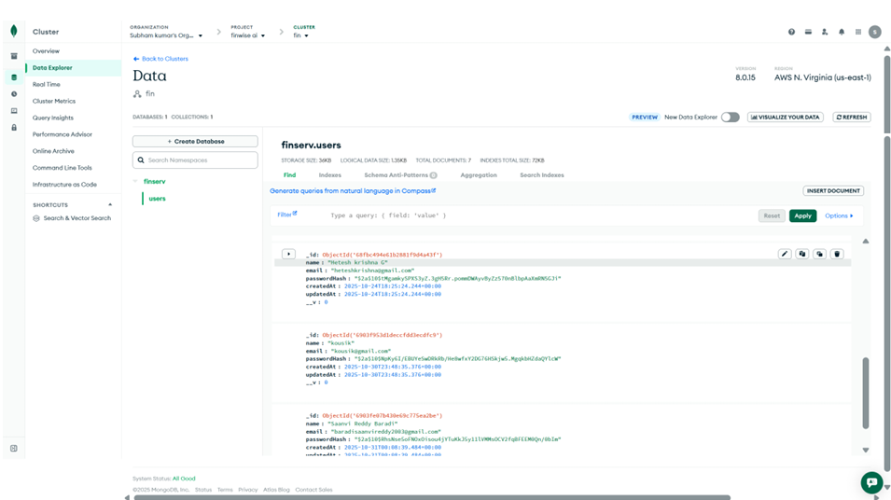

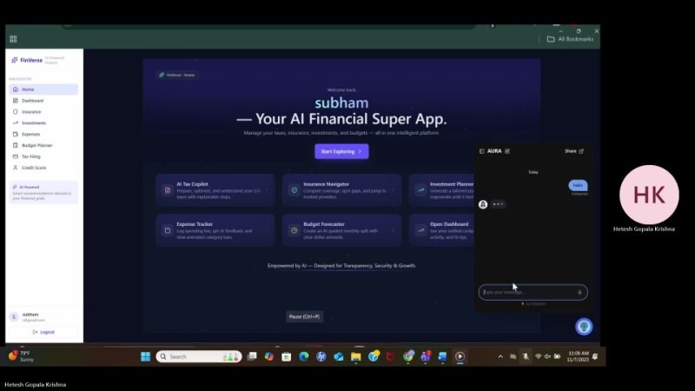

18. Conclusion:
Finverse is a new way to think about managing money that uses AI, keeps your data safe, and makes you feel morally responsible. The point of this project has been to make a system that not only automates hard financial tasks but also does so clearly and dependably. Finverse uses cloud technology, local AI models, and blockchain to make sure that users can handle their money with confidence, knowing that their data is safe and that every AI decision can be tracked.
The project's step-by-step method, which includes planning, integration, training, and evaluation, shows how people and technology can work together well. Each step has been thought to lower risks, make the system work better, and keep people in charge of making choices. Another thing that makes Finverse different is that it is always looking for ways to get better. It uses feedback and performance data to change and grow over time.
By 2030, Finverse wants to be the best in the world at making financial systems that use AI in a way that is fair. The goal is to help people, small businesses, and financial partners in many markets while still being fair, open, and private. By 2030, Finverse wants to expand into new areas, support AI interactions in more than one language, and work with major banks and insurance companies.
Finverse is more than just a place to do business; it's a responsible ecosystem that makes finance smarter, faster, and more focused on people. Finverse is ready to take the lead in the future of financial technology in a way that helps both businesses and society. They will do this by coming up with new ideas, working together, and having strong morals.

